Document template

TITLE:  Brake System Plausibility Device (BSPD)   | SUMMARY:  A Brake System Plausibility Device (BSPD) is a critical safety circuit in electric race cars that prevents unintended acceleration during braking by monitoring brake pressure and motor power.
 | Signature Panel (Wet signature and date)
Prepared by: | Tanvuia Rares-Cristian & Tudoriu Mihnea
Checked by: | Alexandru Anastasiu

Changelog
Issue | Date | Affected pages | Prepared By | Checked By
A | November 2025 | 4 to 5 | Tanvuia Rares-Cristian & Tudoriu Mihnea | Alexandru Anastasiu
B | January 2026 | All | Tanvuia Rares-Cristian & Tudoriu Mihnea | Alexandru Anastasiu
Table of Contents
1. Goals established 4
2. Simulation Design 4
2.1 Co-Simulation principle 4
2.2 Simulation implementation 5
2.3 Simulation Results and Analysis 9
3. Layout 10
4. Conclusions 18

Abbreviation | Meaning
BSPD | Brake system plausibility device
V | Volts
TPS | Throttle position sensor
BPS | Brake position sensor
PCB | Printed Circuit Board
LVMS | Low Voltage Master Switch
EMC | Electromagnetic Compatibility
LDO | Low Dropout Regulator

This page left intentionally blank

Goals established

Our primary goal is to ensure the highest level of safety and reliability in the vehicle’s braking system by implementing a dedicated Brake System Plausibility Device (BSPD). This circuit is essential for monitoring sensor inputs, detecting abnormal or conflicting brake and throttle signals, and triggering an immediate shutdown of the drivetrain when necessary. By integrating this safety mechanism, we align with Formula Student regulations, protect the driver in dynamic conditions, and increase the overall robustness and trustworthiness of the car’s control systems. The BSPD allows our team to operate and compete with confidence, knowing that critical failures are identified and addressed automatically.

Other goals, besides the overall logic of the module, that should satisfy our standards would be to minimize the dimensions of the PCB as much as possible, cost reduction, to ensure voltage stability, noise reduction, thermal performance, power consumption and to utilize more high-end components.

In the following pages, we would like to start the process of designing a real life safety electronic module by taking a step into the simulation world.

Simulation Design

Co-Simulation principle

Why do we need simulation? Simulation represents a must into the electronic domain. We ensure the proper functional logic of the system by creating an imitation of the real-world process, studying how our system would behave in certain configurations. However, simulation limits us to the ideal components and ideal signals applied on the input, which might present a problem, especially in the automotive industry. This is why we extracted real life inputs from our brake position sensor and throttle position sensor using our oscilloscope by generating special format files (PWL file).

Simulation implementation

Furthermore we would like to showcase our simulation process, what went smooth, what went wrong and what we have learnt from this study.

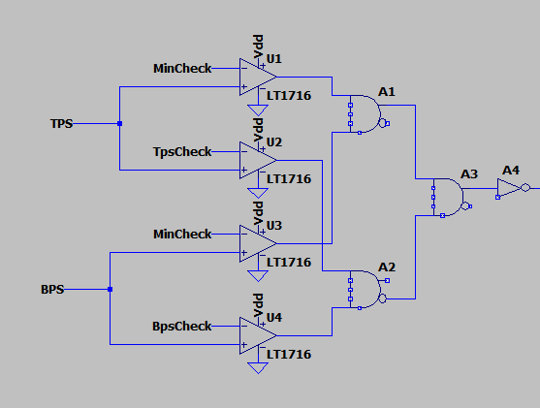
Fig.1.1. LTspice schematic for the first logic block of BSPD.

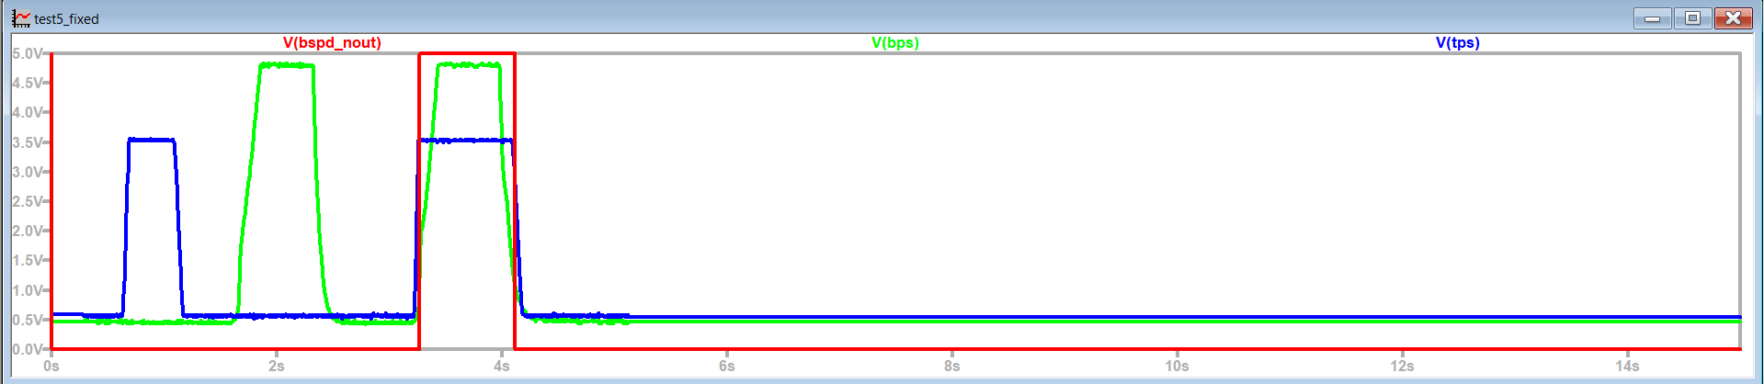
Fig.1.2. LTspice simulation for the first logic block of BSPD.

Having shown above the blue signal (TPS) and the red signal (BPS) which represent the real life signals measured from the vehicle’s sensors, we should establish one principle. While brake pedal and throttle pedal are pressed individually, nothing should happen. Only in the case of both pedals pressed we should get a change in the signal from the BSPD, which can be seen in the green signal.

To be more specific, if we analyze Fig.1.1, MinCheck represents the condition of both pedals being active with a minimum value of 0.3V. This is more of a secure condition to see if the signal are indeed active. BpsCheck and TpsCheck are the main constrain of our system, ordering a change in the output signal only if the accelerator pedal is pressed for more than 25% of the maximum value determined by fully pressing the pedal. In the case of BPS, BSPD should order a change if the brake pedal is considered in hard breaking. The threshold for hard breaking must be chosen such that there are no locked wheels and the brake pressure is ≤30 bar.

By comparing our input signal with our conditions, using four operational amplifiers, we get an output signal that changes whenever conditions are not met, meaning our BSPD will change something in the case of brake and accelerator usage, change that will later become the action of stopping our vehicle.

Our next objective is to start our signal by 0.5 seconds faster. For this step, we decided to implement one 555 timer in monostable configuration, since with only a pulse generated by the action of both brake and throttle pedal we could generate a single square wave, ended by a value set by us using the monostable timer formula:

T = 1.1 * R * C

, a formula that makes it really convenient and easy for us to manipulate the signal.

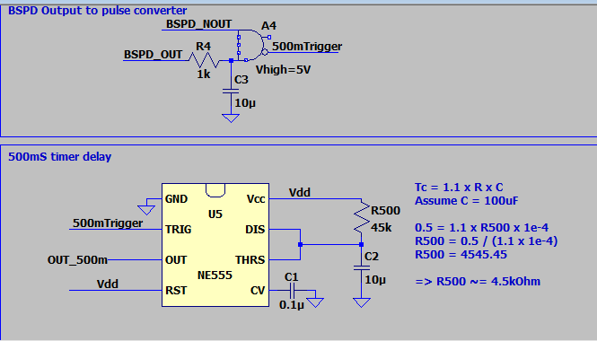
Fig.2.1. Implementation of 555Timer and pulse generator for 0.5s Delay.

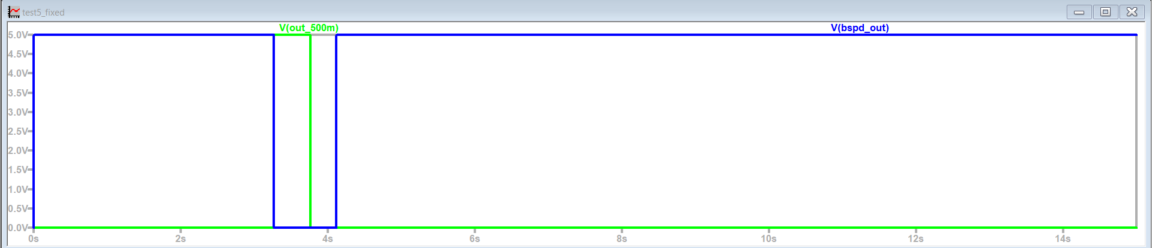
Fig.2.2. Simulation for timer output.

First and foremost, we implemented a pulse generator, a pulse that is created from our BSPD logic output to start the 555timer. It has a simple logic, including both of the same inputs, one inverted and one not. The one inverterted charges a capacitor, so it does not go instantly from high to low, getting time for the logic and gate to detect both signals at high logic for a really short period of time, generating our pulse.

Than our timer, getting input from that pulse, we can manipulate the time period of the wave by the capacitor and resistor values linked to threshold and discharge pins of the timer. That so, we can shorten the signal by 0.5 seconds. To get to our desired signal form ( make a change after 0.5 seconds of detecting something) we add a XOR logic gate, having inputs from our initial BSPD output and our timer output.

The simulation was further extended to cover the remaining safety and control features of the BSPD. A 10 s timer delay was implemented and simulated to ensure that, once a fault condition is detected, the shutdown state is maintained for the required duration, even if the input signals return to normal. This prevents rapid re-enabling of the system and adds an extra safety margin. In addition, a 500 ms timeout pulse was simulated to ensure the 10S timer trigger gives a pulse at 0.5s after the system detects both brake and accelerator input, so that we can create a waveform delayed by 10seconds after the pulse generated.
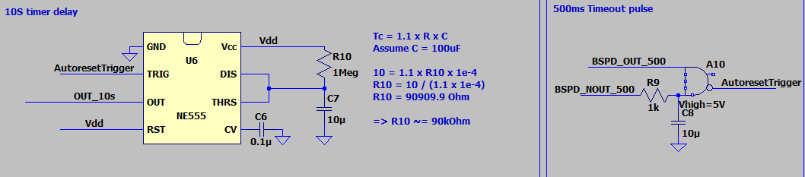Fig.3.1. Implementation of 555Timer and pulse generator for 10s Delay.
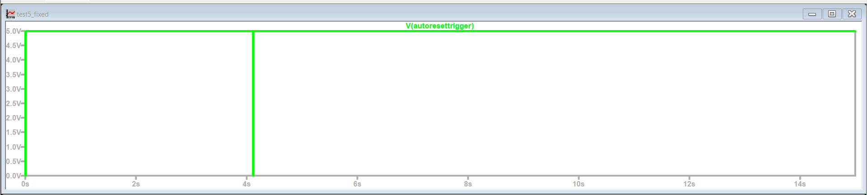Fig.3.2. Waveform of pulse generated as input for the 555Timer.
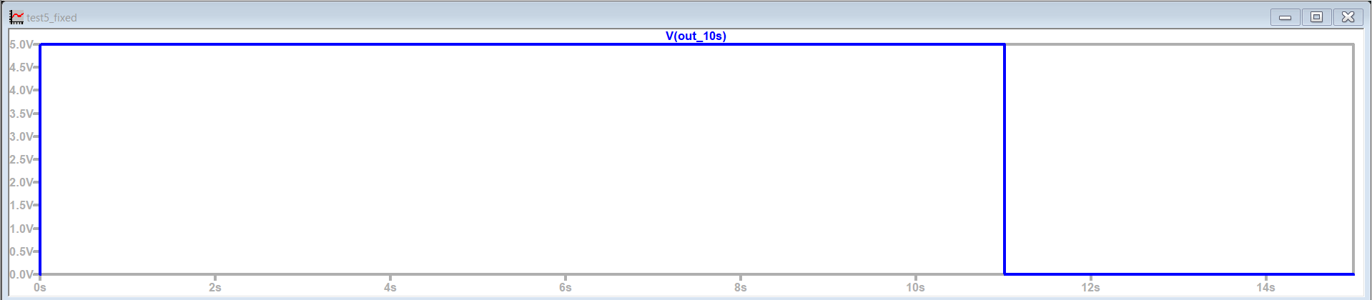
Fig.3.3. Waveform of timer output after the 10S delay.

A BSPD control latch was also included in the simulation to hold the fault state once activated, ensuring deterministic behavior and preventing oscillations or repeated triggering during unstable input conditions. Finally, a startup pulse generator was simulated to guarantee a known and safe initial state at power-up, allowing the system to initialize correctly before normal operation begins. Together, these simulations confirmed stable behavior during startup, fault detection, and reset conditions, completing the validation of the BSPD control logic.
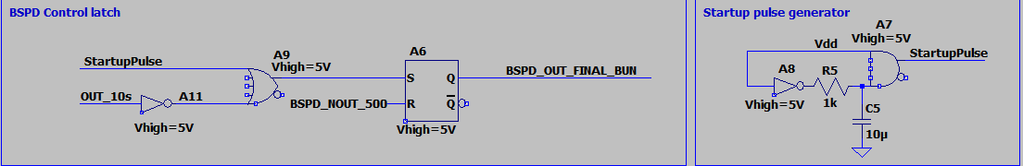
Fig.4.1. BSPD Control Latch simulation design.

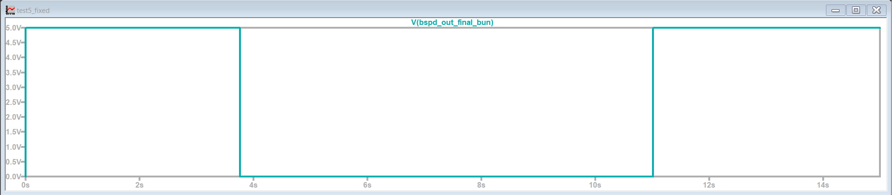
Fig.4.2. Waveform of BSPD output.

Simulation Results and Analysis
Following the implementation of the BSPD logic and the 0.5 s delay stage, multiple simulations were performed to validate the correct behavior of the system under realistic operating conditions. The simulations focused on verifying correct triggering, timing accuracy, and proper reset behavior once the fault condition was removed. Real sensor waveforms obtained from the vehicle were used as inputs, ensuring that the simulation closely reflected real-world conditions. The results confirmed that the BSPD output is activated only when both brake and throttle signals exceed their respective thresholds simultaneously and remain active for longer than the defined delay time. When either signal falls below the threshold, the system reliably resets, restoring normal operation.
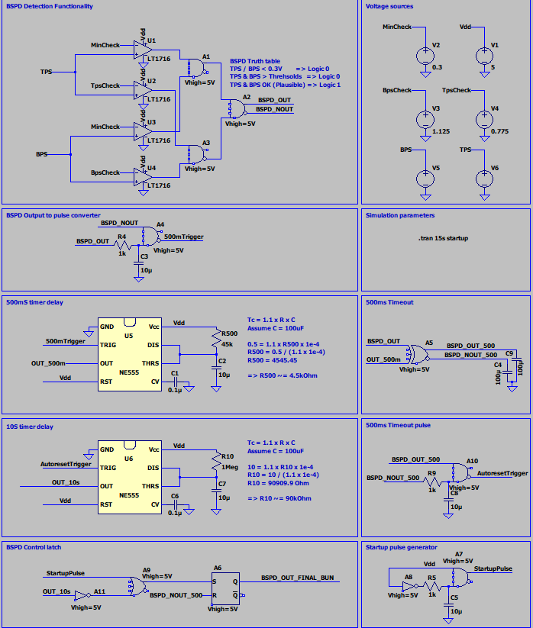
Fig.5. Final logic for the BSPD system.
Special attention was given to transient behavior and noise sensitivity. The simulations showed that the chosen thresholds and filtering handle short disturbances and signal fluctuations well, avoiding false triggers while still reacting quickly in real fault situations. Overall, the results confirmed that the BSPD logic and timing work as intended.

2.4 Simulation first version, lessons learned along the way
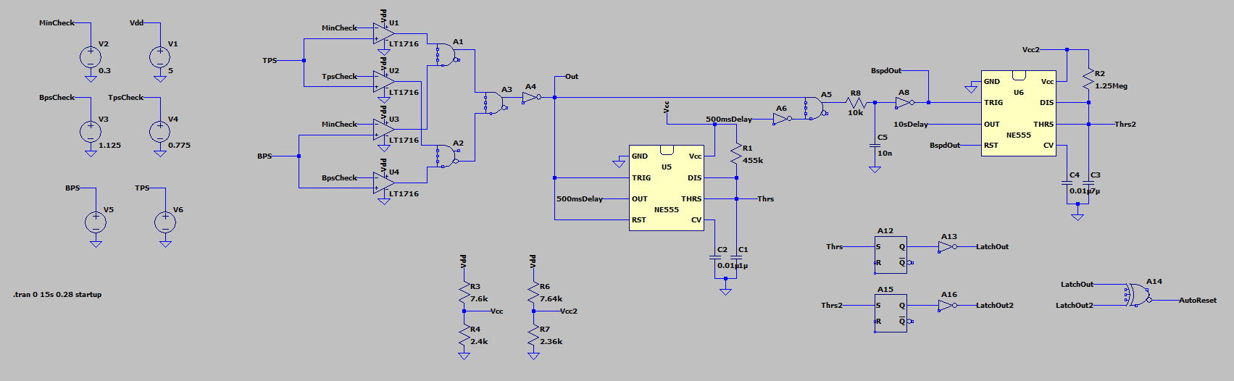
Fig.6. First version of a BSPD system.
The first simulation version of the BSPD, shown in Fig. 2.4, represents an early attempt to integrate all logic, timing, and control blocks into a single system. While the general structure reflected the intended functionality, the simulation revealed several issues that prevented the system from operating correctly. One of the main misunderstandings at this stage was related to the 555 timer, which was initially driven with a static logic level rather than a trigger pulse. As a result, the timer did not behave as expected, and the delay functionality was not properly generated.
Additionally, the interaction between the comparator outputs, logic gates, and timing stages was not yet clearly separated, leading to ambiguous signal transitions and unreliable triggering. These issues highlighted the importance of understanding the functional requirements of each block, especially time-based components such as the 555 timer, which rely on precise edge-triggered behavior. This first, non-working version played an important role in the development process, as it helped identify conceptual gaps and guided the restructuring of the simulation into a more modular and reliable design in later iterations.

3. Layout
3.1 Schematic in Altium Designer

The schematic created for the circuit layout was designed to clearly separate the functional blocks of the BSPD while ensuring reliability and safety in an automotive environment. A key part of the design is the power cutout and noise-triggering section, which uses an optocoupler to safely disconnect the vehicle’s critical control circuits when a BSPD fault is detected. When the BSPD trigger condition is met, the optocoupler provides galvanic isolation and opens the control path, effectively cutting power to the downstream systems and stopping the car in a controlled and safe manner. This approach reduces susceptibility to noise, protects sensitive electronics, and ensures that the shutdown mechanism is robust against ground loops or voltage transients.
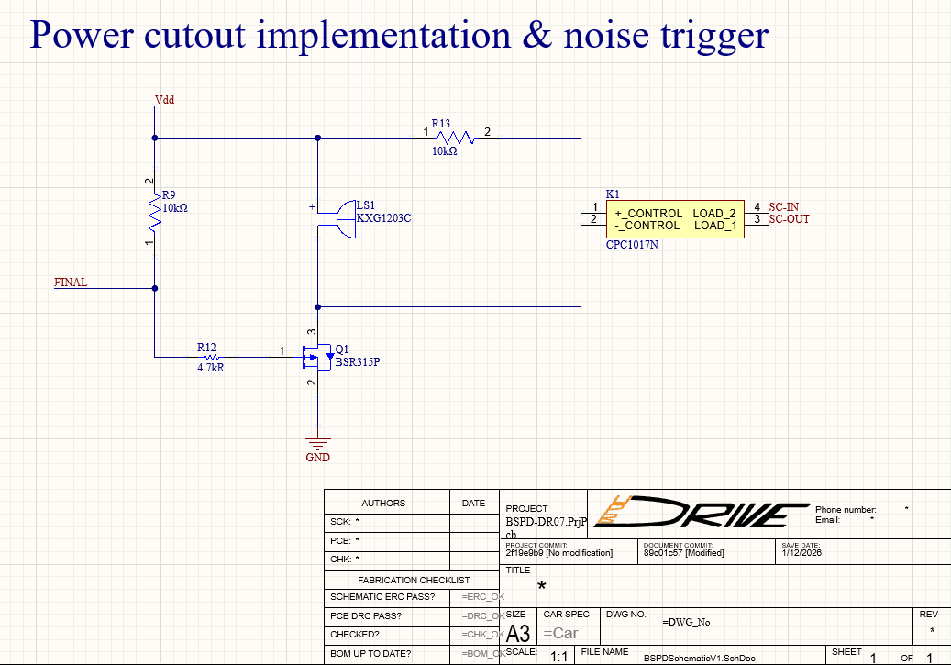
Fig.7. Power cutout implementation in the main circuit.

In addition to the power cutout stage, the schematic includes a dedicated connector input and voltage regulation block. The BSPD is powered from the car’s 12 V LVMS, which is regulated down to a stable 5 V using a low-dropout (LDO) regulator to supply the logic, comparators, and timing circuits. Proper input filtering, decoupling capacitors, and protection components were added to improve voltage stability and noise immunity. Together, these design choices ensure reliable operation of the BSPD under varying load conditions and electrical noise, while meeting the safety requirements for Formula Student applications.
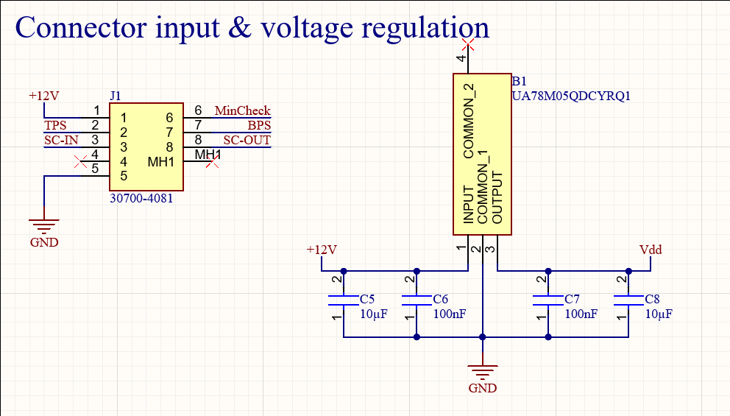
Fig.8. Connector input & Voltage regulation using an LDO and decoupling capacitors.

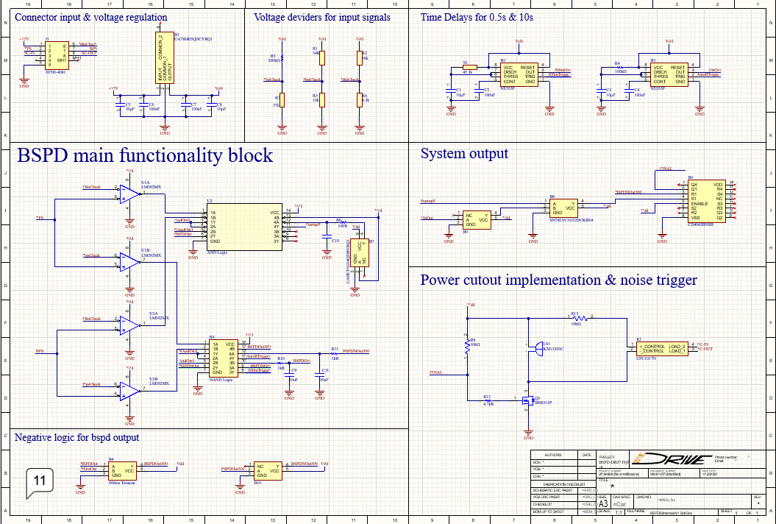
Fig.9. Schematic created in Altium Designer for the BSPD module.

3.2 PCB Layout Design

The finalized schematic was then imported into the PCB design environment. Proper component footprints were assigned by the manufacturers of the components, and electrical rules were verified before proceeding with layout. Net classes and clearance rules were defined to ensure safe separation between low-level signal paths and power-related traces.

The PCB layout was designed with an emphasis on reliability, noise reduction, and compact size. Sensitive analog and logic signals were routed with short trace lengths and proper grounding to minimize interference. Power traces were widened to handle expected currents safely, and decoupling capacitors were placed close to their respective components. The final layout achieved a compact form factor while maintaining clear signal integrity and thermal performance, making it suitable for installation in the vehicle.

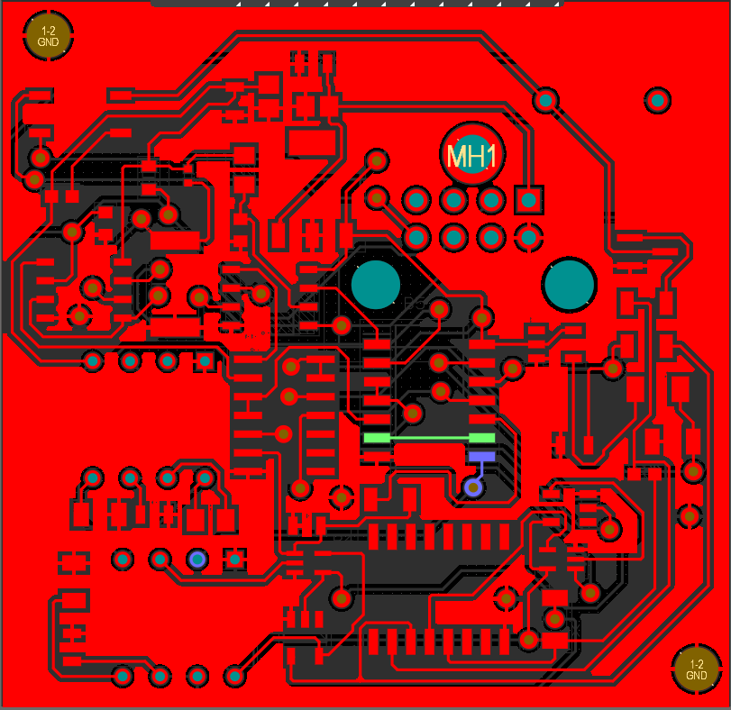
Fig.10.1. Top copper layer in 2D.

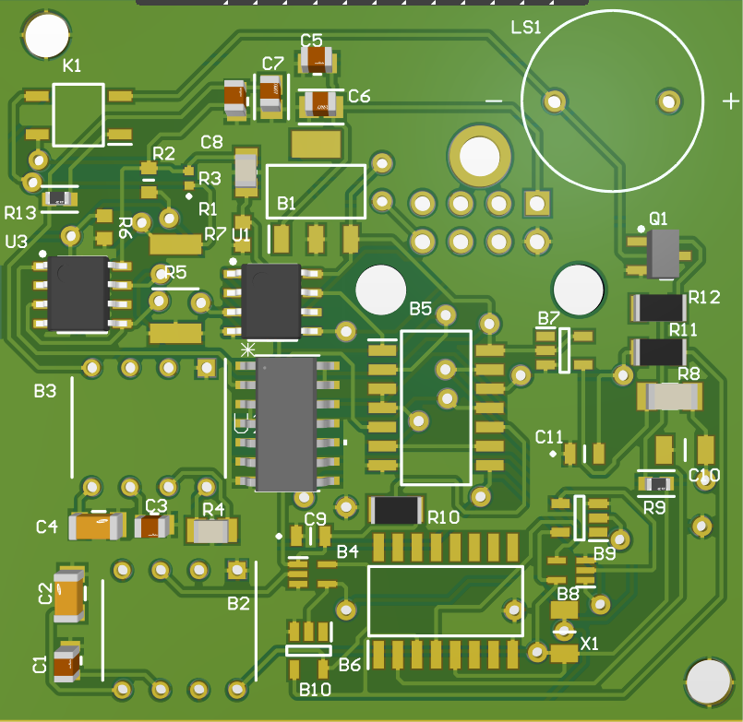
Fig.10.2. Top layer in 3D.

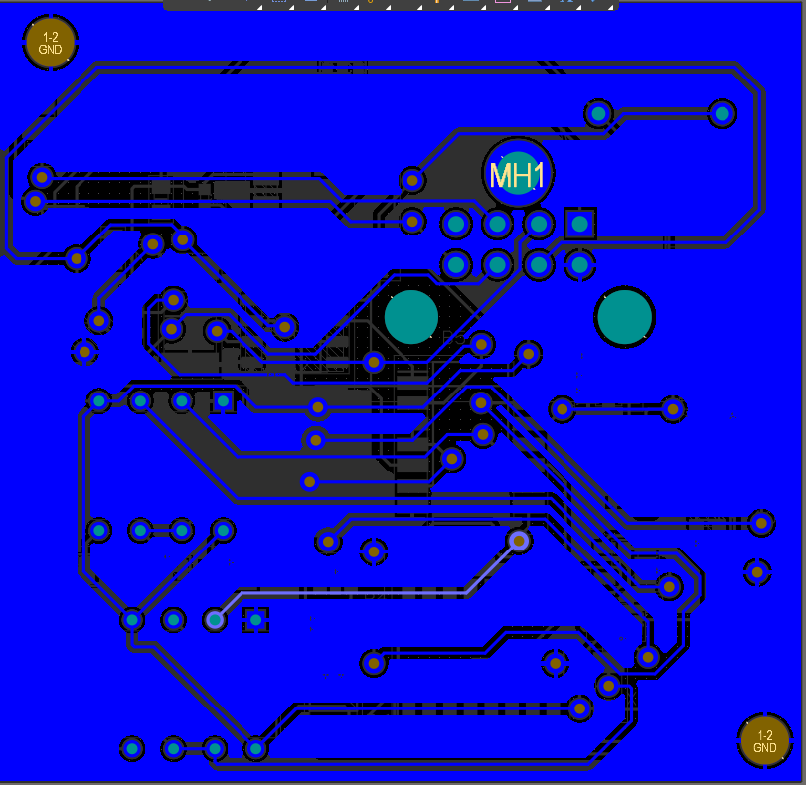
Fig.11.1. Bottom copper layer in 2D.

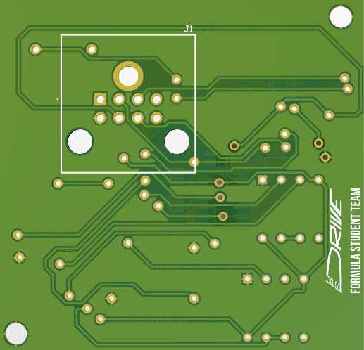
Fig.11.2. Bottom layer in 3D.

From an EMC perspective, routing was done with ground kept as close as possible to fast-changing or sensitive signals, reducing impedance and limiting noise coupling between traces. Decoupling capacitors were placed close to supply pins, and power and ground routing was designed to avoid long, high-current loops. Additionally, via stitching and ground connections were used to further improve return paths and overall noise performance.
However, from a microwave point of view, we tried to take into consideration any reflection that might occur between traces, from 90 degrees angles of traces to different widths of traces, to connecting pads through traces not from pad to pad, we made sure to minimize any unnecessary noise generation.
Finally, drill holes were carefully chosen and placed not only for vias and through-hole components, but also to allow the future integration of a mechanical enclosure. Mounting holes were positioned to support a stable case design, ensuring the BSPD module can be securely fixed inside the vehicle while maintaining electrical isolation and mechanical robustness.
3.3 Layout design first versions and lessons learnt.

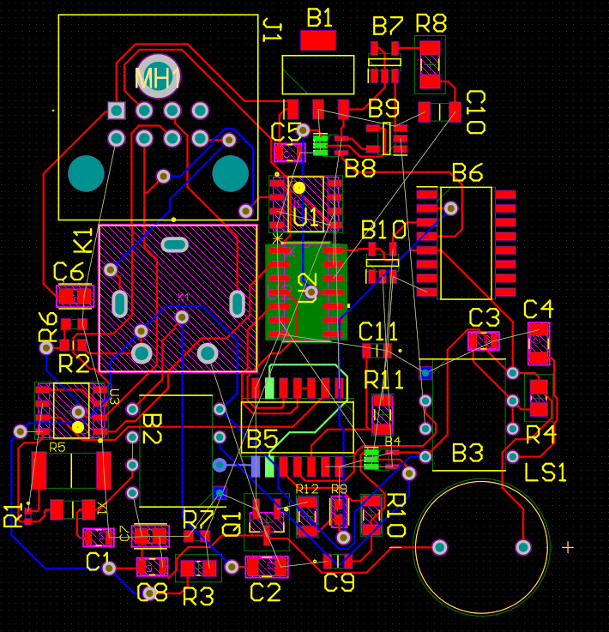
Fig.12. First version of the BSPD PCB Design.
This layout represents the first PCB version of the BSPD module, which was mainly used as a functional and learning prototype. While the circuit met the basic electrical requirements, the initial placement of components and connectors was not optimized for size or routing efficiency. In this version, several connectors were placed on the top side of the board together with dense logic and power components, which resulted in longer trace paths, more layer transitions, and limited flexibility in component placement. As a result, routing became more complex and the overall board dimensions were relatively large, approximately 7.5 cm by 7 cm.
Based on these observations, a second design iteration was started. One of the main changes was relocating the connectors to the bottom side of the PCB, physically separating them from the more sensitive logic and timing components. This allowed a more compact and structured placement of components, shorter and cleaner routing, and improved signal integrity. By rearranging the functional blocks and optimizing trace paths, the board area was significantly reduced to approximately 3.5 cm × 4 cm. This redesign not only improved manufacturability and EMC behavior, but also made the module easier to integrate mechanically into the vehicle, demonstrating the importance of iterative PCB design and layout optimization.

Conclusions
The BSPD module was successfully designed, simulated, and implemented following a structured engineering approach. Simulation using real sensor data played a key role in validating system behavior and identifying optimal design choices. The final schematic and PCB layout meet the functional, safety, and integration requirements of the vehicle, providing a reliable solution for preventing unintended acceleration during braking.

